Biology Semester 1 Final Study Guide

Go to www.mchsbio.weebly.com for all power points and notebook sheets from the entire semester!

Unit 1 - Intro to Science:

1. Know the parts of the microscope
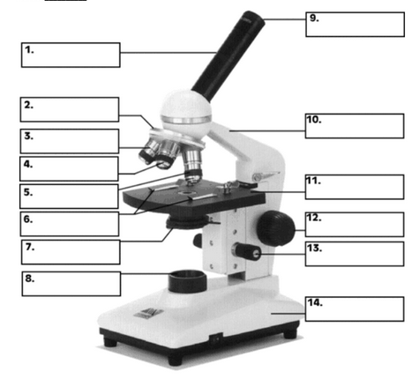
2. What characteristic must a hypothesis have?

3. How many variables does a valid experiment have?

4. Define independent variable and dependent variable.

5. Describe qualitative and quantitative data. (Give examples)

6. Convert 60 centimeters to meters. (Show work)

7. Convert 5.6 meters to centimeters. (Show work)

Unit 2 - Ecology:

8. Ecology comes from the Greek word meaning ________________.

9. Write the levels of ecological organization from smallest to largest below.

10. Write a description for each level of ecological organization. (What is found at each level, how it is different from all other levels, etc…)

- _____________________________ -

- _____________________________-

- _____________________________-

- _____________________________-

- ____________________________-

- ____________________________-

11. Define biotic –

12. Define abiotic –

13. What does a tolerance curve measure?

14. What is the difference between acclimation and adaptation?

15. Define fundamental niche –

16. Define realized niche –

17. What increases in the blood during elevation acclimation in humans?

18. Define conformer –

19. Define regulator –

20. Identify what type of organisms are being graphed in the two lines below:
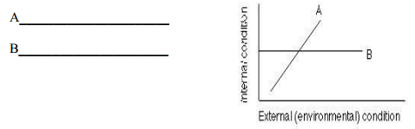
21. Identify the types of dispersion patterns below:
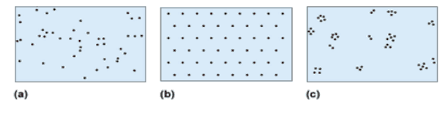

22. Identify the types of models below:
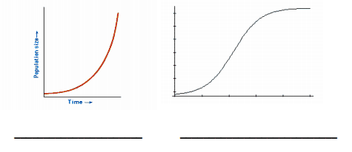
23. What is the abbreviation for carrying capacity?

24. Identify the types of symbioses based on the (+,-) interactions:

25. Define the following terms:
Herbivore-

Carnivore-

Omnivore-

Detritivore-

Decomposer-
26. Draw 10 arrows in the correct direction!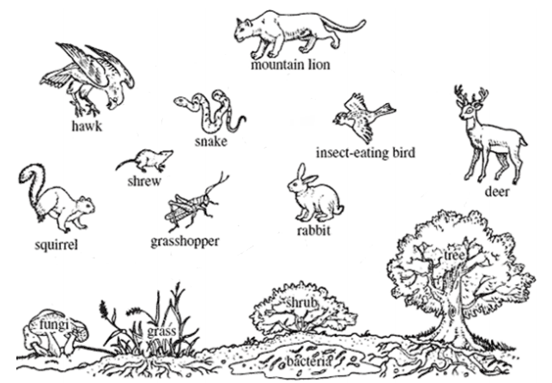

Unit 3 - Biochemistry:

27. Describe the difference between chemical and physical changes:

28. Define the following terms:

Ionic bond-

Covalent bond-

Van der Waal force-

29. Balance the following equations:

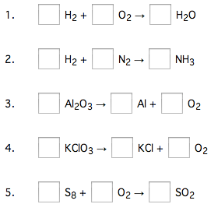

Unit 4 - The Cell:

30. Describe the 3 parts of the cell theory.

31. Who is the scientist who first coined the term “cells”?

32. What is the plasma membrane mainly composed of?

33. Describe the 6 types of cellular transport (passive and active).

35. What is an autotroph?

36. What is a heterotroph?

37. Define metabolism:

38. What is ATP used for in the cell?

39. What is the chemical equation for photosynthesis?

40. What are the 2 phases of photosynthesis?

41. What are the 2 phases of cellular respiration?

42. Define aerobic and anaerobic:

43. Where does all energy come from?

44. What defines something as living?

45. Define homeostasis:

46. What passes easily through the cell membrane?

47. What is the job of a transport protein?

48. What is the job of carbohydrates on the cell membrane?

49. What is the job of cholesterol in the cell membrane?

50. What is another name for cell membrane?

51. What does selectively permeable mean?

52. Hydrophilic ___________________________ water.

53. Hydrophobic __________________________ water.

54. 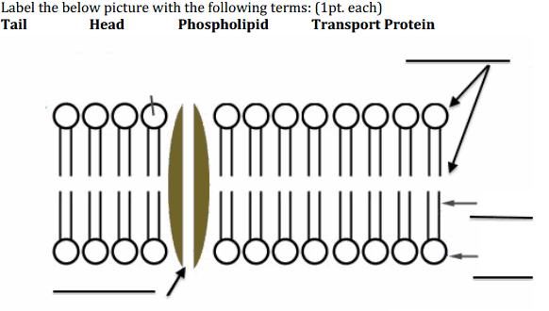
55.
Look at the pictures below, and write the correct type of solution underneath :
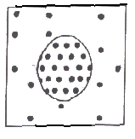 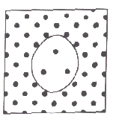 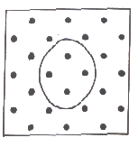_________________ __________________ _________________

Unit 5 - Mitosis/Meiosis:

56. What are the 6 stages of the cell cycle, in order, and what occurs in each stage? (drawing pictures might help).

57. What stage of mitosis takes the longest?

58. How many daughter cells are produced in mitosis?

59. How many daughter cells are produced in meiosis?

60. How much DNA do the daughter cells have in comparison to their parent cells after mitosis?

61. How much DNA do the daughter cells have in comparison to their parent cells after meiosis?

62. What is apoptosis?

