Modeling the Phases of the Cell Cycle
Introduction:
In a growing root, the cells at the tip of the root are constantly dividing. Because each cell divides independently of the others, a root tip contains many cells at different phases of the cell cycle. This makes a root tip an excellent tissue in which to study the cell cycle. In this investigation, you will identify and describe the phases of the cell cycle in root tip cells.

Problem:

What do the phases of the cell cycle look like in a typical plant cell?

Materials:

- Lab form
- Microscope
- Prepared slides of onion root tips
- Colored pencils, crayons, or highlighters

Skills:
Classifying, Using Models, Data Analysis

Procedure:

- In the spaces below write a description and draw what a cell would look like in each of the phases of the cell cycle (Interphase, Prophase, Metaphase, Anaphase, and Telophase).

Description Drawing
Interphase
Prophase
Metaphase
Anaphase
Telophase

- Look at the diagram below. This is a picture of an onion root tip taken through a microscope.

- Identify the cells that are in each stage of the cell cycle and color them a particular color. The colors to use are listed below:
Interphase –Blue

Prophase- Yellow

Metaphase -Orange

Anaphase - Green

Telophase - Purple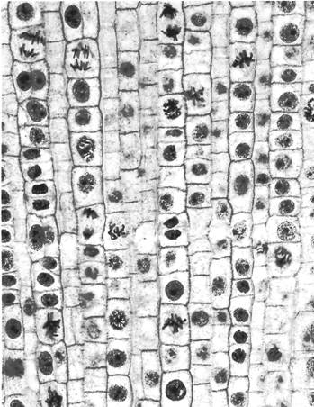

- How many cells are in each phase?

  - Interphase: ____________
  - Prophase: ______________
  - Metaphase: ____________
  - Anaphase: _____________
  - Telophase: ____________
  - TOTAL CELLS ___________

- Create a bar graph of the data above in the space below.
- Look at a slide of onion root tip cells under a microscope.

- Observe the boxlike cells that are arranged in rows. Look at the cells carefully and compare them. The chromosomes of the cells have been stained to make them easily visible.

- Select a cell to draw for each of the phases of the cell cycle in the spaces below using the microscope.

Interphase | Prophase | Metaphase | Anaphase | Telophase

Analysis and Conclusions:
- Do your results indicate that there were more cells in some phases than in others?

- Which phase was most common? Why do you believe this is true?

