Pedigree Analysis Notes

____________________ of Pedigree Analysis

1. Determine the mode of _____________________________: dominant,

_____________________________________, partial dominance,

_______________________________, autosomal, mitochondrial, maternal effect.

2. Determine the __________________________ of an affected offspring for a given cross.

Pedigree Analysis is a Key Tool in Human Genetics
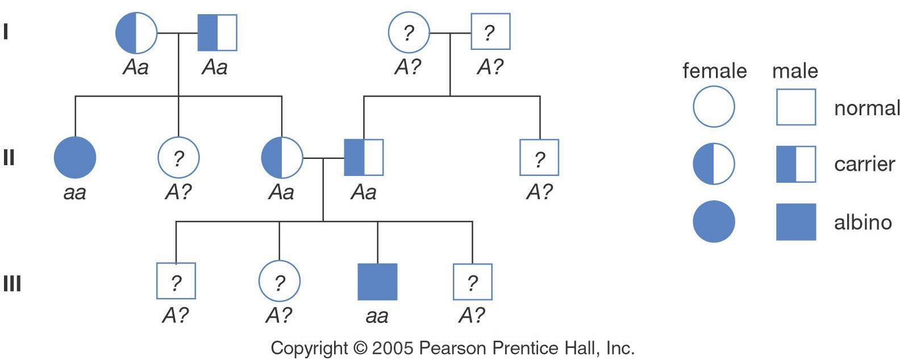
- Analyzing a pedigree is like ____________________ - building – you try assigning

______________________ genotypes until the pieces fit.

Pedigrees: Basic rules
=

=

=

=

- People who have children together are connected by a ____________________ line.
- Their children are connected to them with a _________________ line.

- Each generation is assigned a ____________ numeral, beginning with the earliest

  - Examples: _______________________

- Individuals w/in _______________________________ are assigned ______________________ numerals, beginning with the left.

  - Examples:________________________
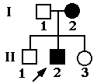

Patterns of dominant traits

- Trait ___________________ to appear __________________ generation

- About equal _______________ between ____________________ males and affected

_______________________.

- At least one ___________________ must be affected in order for ___________________ to be affected
  - Aa x aa
- Normal parents will always produce ______________________ offspring.
  - aa x aa ---> aa

Autosomal Dominant Pedigree
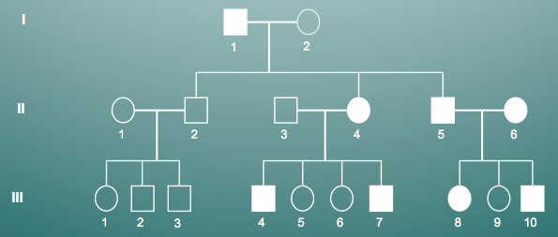

Patterns of recessive traits

- may appear to “___________________” generations

- About __________________ ratio between affected males and affected females

- _____________ children of normal and affected parents are _______________________.
  - AA x aa ---> Aa

- _____________ children of two affected parents will be affected
  - aa x aa ---> aa

- normal parents ______________ produce affected offspring
  - Aa x Aa ---> 3/4 normal; 1/4 affected
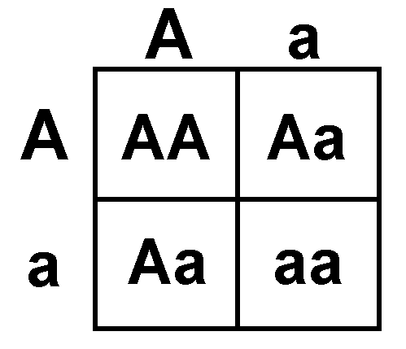

Autosomal Recessive Pedigree
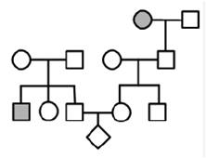

X-Linked Recessive

- __________________ males affected than ____________________

- Males get their __________ from their mother and _________ from their father.

- Females get one _______ from mom and one _________ from dad.

- Trait ____________________ in males if present.

- Recessive in females and are __________________________

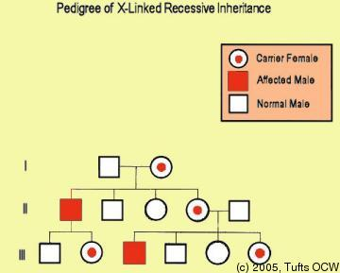

Sum it up!
Autosomal Dominant
- Males and Females
- Every generation

Autosomal Recessive
- Males and Females
- Skips generations

X-linked Recessive
- More males than females

