Meiosis
- Formation of Gametes
- Meiosis only occurs in the _____________________________ cells…all other cells undergo _______________________
- Ending products of meiosis are _____________________ gametes
  - ____________ in female - __________________________
  - Sperm in ___________ - ___________________________
- Fusion of ________________ and egg results in a ____________________ cell

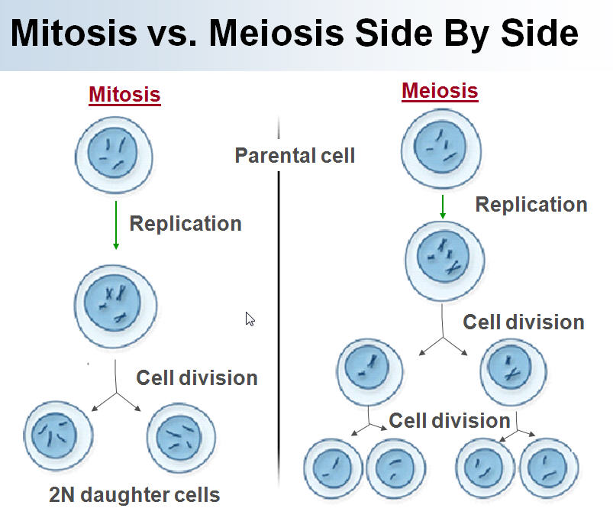

- Meiosis does ______________ things…
- 1) Meiosis takes a cell with _______ copies of every chromosome (______________) and makes cells with a ________________ copy of every _____________________________ (____________________).
- This is a good idea if you’re going to ______________________ two cells to make a new ________________________. This trick is accomplished by ______________________ chromosome ___________________________.
- In meiosis, one ____________________ cells produces _______________ haploid cells.
- 2) Meiosis ______________________ the specific forms of each ______________ that each sex cell (______________ or _______________) receives.
- This makes for a lot of genetic ___________________________. This trick is accomplished through _____________________ __________________ and ________________________________.
- Genetic diversity is important for the ___________________________ of populations and ____________________.
- Crossing Over
- ________________________ - homologous pairs line up = tetrad
- During synapsis the chromatids within a homologous _________________ may twist around each other and break off and _________________ to the other homologous pair = ___________________ ______________
- Results in exchange of _____________________ material between _____________________ and ________________________ chromosomes = genetic ________________________
- 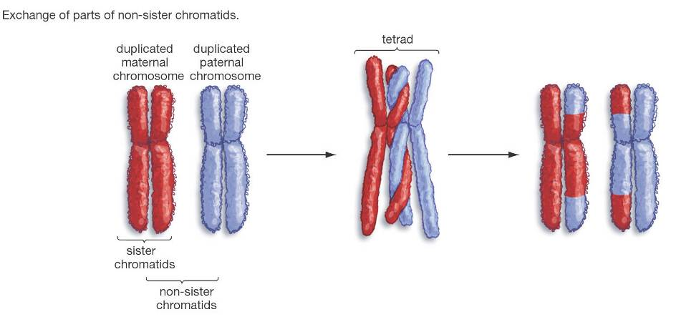
- Law of _________________________ Assortment
- During metaphase, as the homologous pairs ___________ up the orientation of maternal and paternal chromosomes is ______________________.
- As the homologous pairs are ____________________ in _____________________, the maternal and paternal chromosomes have random _______________________.
- Results in ________________________ variation.
- Karyotype
- 46 chromosomes, ___________ pairs
- One of each pair was from ____________, one from ______________
- 