Cell Growth Limits and Cell Cycle
Limits to Cell Size
- Most cells are less than __________________________________which is smaller than a period on your paper.
- The key factor to why cells are so small is the _________________________________________________________________________________________________________________________________________________________________________________.
- Surface Area = __________________________________________________________________________________________________________________________________________________________________________________
- Volume = __________________________________________________________________________________________________________________________________________________________________________________
- The surface of a cell is covered by the cell _____________________________ and allows __________________________ and ___________________ to enter/exit the cell.
- If the cell is too big, the ________________________________ inside the cell is ____________________ and ___________________________ so the cell parts will not get all the things they need to ____________________________.
- Cells also need to ___________________________________ with all of their organelles and other cells, if the _______________________________ of a cell is too big the __________________________________ can take too long and the cell will _______________.

The Cell Cycle
- Once a cell reaches it’s _____________ __________________ it has to divide or stop growing. Most __________________________.
- The cell _________________________ is also a way for the cell to _____________________ and __________________.
- Every time a cell goes through the cycle, it will become _________ cells.
3 Stages of the Cell Cycle
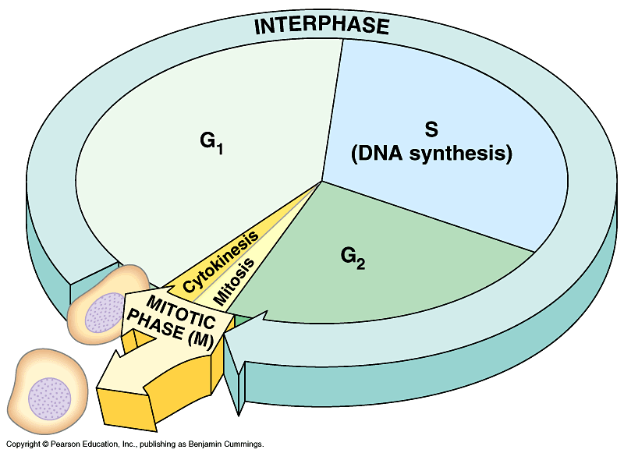
- There are _________ main stages:
- __________________________ - this where the cell __________________, carries out it functions, and makes ______________________ of its ________________.
2. Mitosis- _________________________________________________________________________
3. ____________________________ - the ________________________ of the ______________________ and all organelles.
- The cell cycle can take as little as __________ hours or as long as a _______________ but most cells go through it in ___________________________.
Stages of Interphase
- Interphase is the part of the cell cycle where the cell ____________________ and ______________________________ and this is broken down into _________ phases.
- 1. Gap 1 or ______________.
- 2. Synthesis or _________.
- 3. Gap 2 or ___________.
Gap 1 (G₁) Phase
- When does G₁ phase happen?

- What happens during G₁ phase?

- Some cells _______________ the cycle at this phase and never ______________________ like ___________________ and ___________________ cells.

Synthesis (S) Phase
- What happens during S phase?

Gap 2 (G₂) Phase
- What happens during G₂ phase?

- After this phase the cell enters ___________________ and __________________________.

