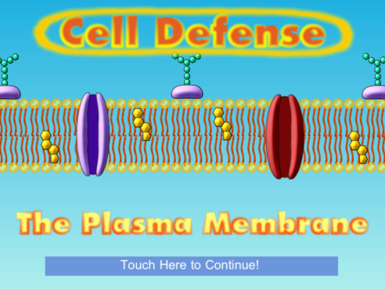
Name: ____________________

Date: _____________________

Period: ___________
Cell Defense
The Plasma Membrane

Background:
- Homeostasis is the ______________________________________________________________________
_________________________________________________________________________________________
- The structure in a cell that is mostly responsible for this is the _______________________________
_________________________________________________________________________________________
- It is the barrier between the environment and the inside of the cell.
- It selectively allows materials in and out of the cell. This process is called ___________________
__________________________________________________________________________________________

Directions: Read the steps here and all the information on the iPad screen. Follow all the steps carefully filling in all the blanks.

Step 1: Click touch here to begin the app. You want to move to the “Choose Your Challenge!” menu. From the menu choose “Build a Membrane!” Dr. Vial has a vile weapon (note the play on words) that destroys plasma membranes. Without _______ ________________ cells of living things will die because they are unable to maintain _________________________.

Step 2: Zoom in on the plasma membrane. From the “Urgent Message” you learn that phospholipids are a ________________ Head and __ __________ ________ TAILS.
The heads are _______________________________ which means ______________________________.
The tails are ________________________________ which means _______________________________.
The heads face out towards the ________________ and the tails facing ____________ _________.
Draw and label the phospholipid in the box:

Step 3: Repair the phospholipid membrane.
How many phospholipids did it take? _______

Step 4: What do you have to put into
the membrane in order to help stabilize it?
___________________________________ How many did you add? _____

Step 5: What is another word for selectively permeable? _________________________________.
What does that mean? __________________________________________________________________
________________________________________________________________________________________.

Step 6: What 2 molecules easily pass through the membrane? Record why for each.
Molecule 1 | Molecule 2

Step 7: What 3 molecules cannot easily pass through the membrane? Record why for each.
Molecule 1 | Molecule 2 | Molecule 3
What does polar mean? __________________________________________________________________________________________

Step 8: Insert channel proteins into the membrane. Transport substances across the membrane. Note: You can only transport substances using channel proteins until there were
_________________________________________________________________________________________. What is this process called? _____________________________________________________________

Step 9: Moving from ______ to _______ concentration requires the use of energy to _________ substances. This is called ______________________________ transport and uses: (place answer in table)
1. | 2.  Which is cell ______________

Step 10: Carbohydrates are like identification badges. Cells that have different membrane carbohydrates do different ________________. The immune system uses the carbohydrates to _____________________ that your cells belong to ________ and are not ______________________, ____________________, or other foreign cells.
What does the immune system do to foreign invaders? ____________________________________
What kind of cell does this? ______________________________________________________________

Step 11: Next take the “Membrane Structure Challenge!”

Step 12: Take the “Diffusion Challenge!”
Dynamic equilibrium is when the molecules have _________________________ and are ____________________________________ on both sides of the membrane.

Step 13: Take the “Energy and Transport Challenge!”
Why can’t sugar pass through the phospholipid bilayer on its own? __________________________________________________________________________________________
Without sugar, the cell is not able to make __________ and will ___________.
How many ATP did you use? ______ What type(s) of protein(s) were used? __________________
_________________________________ Explain when each type was used. ______________________
__________________________________________________________________________________________
__________________________________________________________________________________________

Step 14: Take the “Osmosis Challenge!”
What is Osmosis? _________________________________________________________________________
__________________________________________________________________________________________
__________________________________________________________________________________________
The tricky thing about osmosis is that we talk about ________________________________________
rather than ________________________________________.
____________________ are the substances that are ____________________________ in the water.
_________________________ = higher in solute
_________________________ = lower in solute
_________________________ = equal in solute
What is the name of the special proteins that let water pass through? ______________________
Is this passive or active transport? ______________________________________

