Chemical Reactions:
Reaction Energy, Water & Macromolecules

- Chemical reactions need _____________________ .

- __________________ = Energy

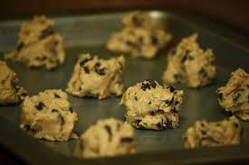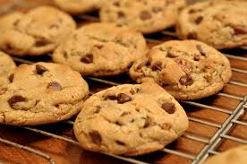

Activation Energy

- _____________________ amount of energy needed for reactants to form ______________________ in a chemical reaction

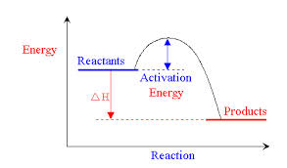

Exothermic
- Energy is released (Gives off ______________)

- Product energy is _______________________ than reactant energy.
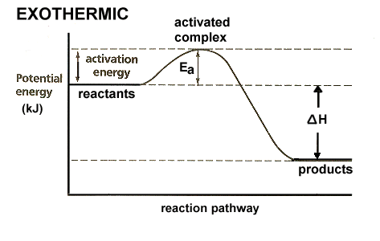

Endothermic
- Energy is absorbed (_________________ effect)

- Product energy is ____________________ than reactant energy.

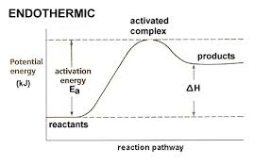

Enzymes/Catalysts

- Catalyst – ____________________ that lowers activation energy

- Enzyme – ____________________ that lowers activation energy

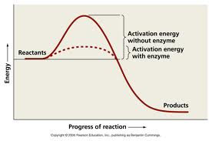

Water

- H₂O

- ____________________________ bonds

- Electrons spend more time around ______________________ molecule

- _____________________ molecule – charges are uneven throughout the molecule

Mixtures with water

- Homogenous – _____________________________ throughout (solution)

- Heterogeneous – ____________________________ throughout (suspension)

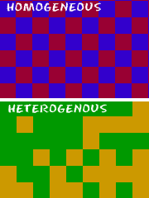

Acids vs. Bases

- Acids – release ________________________ ions (H⁺) when dissolved in water

- Bases – release ________________________ ions (OH ⁻) when dissolved in water

- pH = ______________________________

Buffers

- Mixture that can react with acids or bases to keep the ____________ in a certain range
- Blood = ________________

Macromolecules

- Macromolecules - ___________________ molecules formed by ___________________ smaller molecules together

- Polymers – _______________________ units of identical compounds called monomers

