Chemical Bonds

- ___________________________ bonds

- ___________________________ bonds

- ___________________________ forces

Covalent Bonds

Definition –

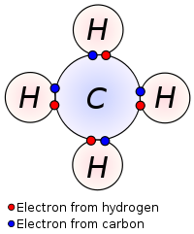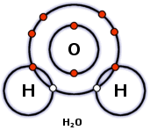

Ionic Bonds

Definition –

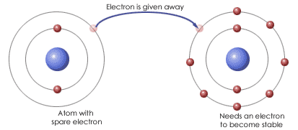

Van der Waal Forces

Definition –

- ____________________ than covalent and ionic bonds
- Like a

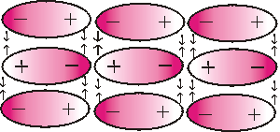

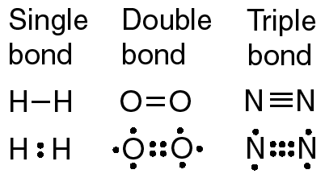

Chemical Reactions

- Process by which _____________ reorganize into different substances

- Chemical bonds are ________________ and/or formed

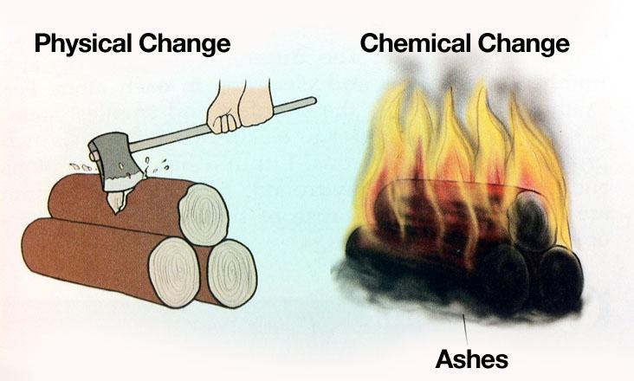

Reactant and Products

- Reactants = ____________________ material

- Products= _____________________ material

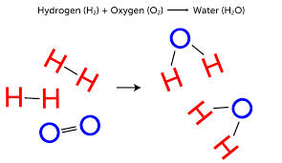
Parts of a Formula Equation

