Name:_______________________________________
Period:__________________
"CENTRAL DOGMA OF GENETICS"
(DNA Processes Made Simple by Miss Vercelli)
Step 1: DNA Replication
- What happens? DNA is copied.
  - Base pairs:
    - A ➔ T
    - T ➔ A
    - G ➔ C
    - C ➔ G
- DNA Strand: A T C G T A C C G T T T T A A C G
- Complementary Strand: T A G C A T G G C A A A A T T G C
- You try:
- DNA Strand: T G C C C G T A T A G C C G G T T
- Complementary Strand: ___________________________

Step 2: Transcription
- What happens? DNA gets changed to RNA
  - In RNA, Thymine (T) is replaced by Uracil (U)
    - A ➔ U
    - T ➔ A
    - G ➔ C
    - C ➔ G

- DNA Strand: A T C G T A C C G T T T T A A C G
- RNA Strand: U A G CA U GG C A AA A UU G C
- You try:
- DNA Strand: T A T T G T C C G A T G G C A A T
- RNA Strand: ___________________________
RNA is read in codons (3 letters at a time)
- RNA Strand: U A G C A U G G C A A A A U U G C U
- RNA Strand in codons: UAG – CAU – GGC – AAA – AUU – GCU
- You try:
- RNA Strand: A U C C U U A G C U C A G U C G C A
- RNA Strand in codons:___________________________________

Step 3: Translation
- What happens? RNA codons get changed to an amino acid chain.
  - Need to use “RNA codon to amino acid chart” to translate.
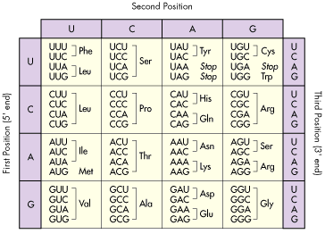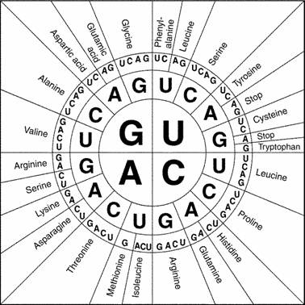
- RNA codons: UAG – CAU – GGC – AAA – AUU – GCU
- Amino acids: stop – His – Gly – Lys - Ile - Ala
- You try:
- RNA codons: UUU – GCG – AGU – UAA – ACC – GGC – CCC
- Amino acids: _____________________________________

Step 4: Protein Synthesis
Amino acid chain ➔ Protein ➔ Gene ➔ Trait

