Translation
- mRNA, or __________________________________________, leaves the nucleus and arrives at the ribosomes
  - Once the mRNA arrives at the ribosomes, we refer to the process as _____________________
  - Think of the ribosomes as factories that put together proteins
- In the ribosomes, the mRNA gets read in groups of 3 called _________________ that represent __________________________________________
  - Which are the building blocks of _____________________________
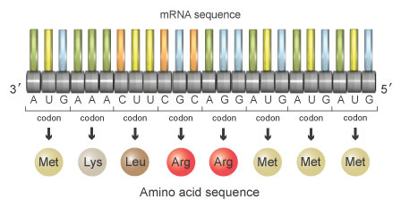
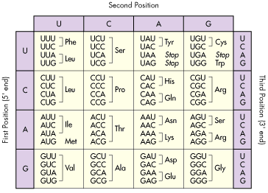

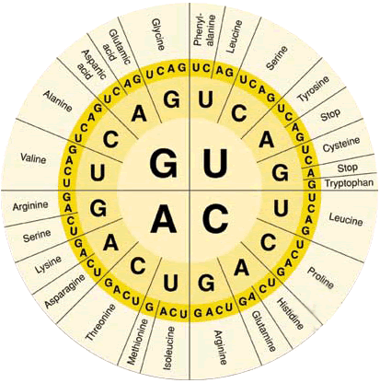

- Ex)
  - mRNA: U C U
  - amino acid: _ _ _
  - mRNA: C C G
  - amino acid: _ _ _
  - mRNA: U U A
  - amino acid: _ _ _
- Once the ribosome reads the codon, it releases an amino acid that comes from that codon
  - As more amino acids are coded for, the connect to each other by _____________________________________

- This process begins with a ______________________________________ and ends with a _____________________________________
    - Start: AUG
    - Stop: UAA, UAG, UGA

