Nature Cycles

- Cycles have no ______________ or ___________ (circle)
- Three cycles that moves matter among the environment and living things are:

  - ____________________ cycle

  - ____________________ cycle

  - ____________________ cycle

Water Cycle

- The movement of water among ________________,

atmosphere, ________________, and living things.

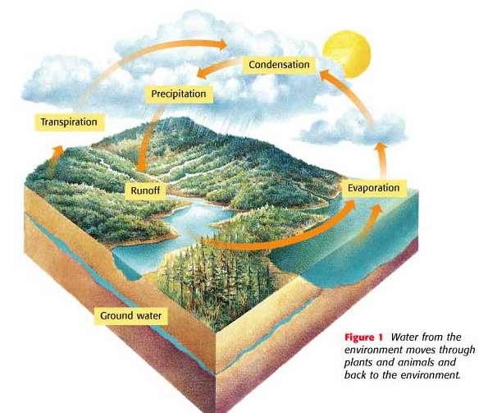
Carbon Cycle

- The movement of carbon from the _________________________

into living things and ______________ again.

- Carbon is ________________________ to all living things because

it is part of our _________________________________.

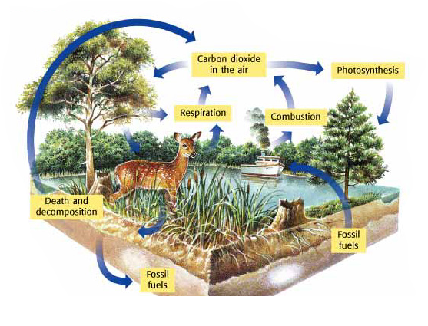

Nitrogen Cycle

- The movement of nitrogen from the environment to

_____________________ things and back again.

- __________% of our atmosphere is nitrogen gas

- Plants and animals need nitrogen to make _________________

and _________________.

