DNA Replication
- The original DNA strand acts as a ____________ for the new ones.
- The new cell’s genetic information will determine the _______________ and ______________ of the new cells.
Step 1
- Parent DNA strand starts to “unzip” and the weak ______________ bonds between nucleotides split, forming the _________________________
- The enzyme, DNA _______________, helps this “unzipping” process
Step 2
- ______________ helps bind free base pairs with their complementary bases on the parent strand
- complementary: fitting together properly
  - ____ → ____
  - ____ → ____
Step 3
- _______________ follows the process and forms ______________ bonds in the backbone of the new DNA strand
  - this ensures that the new strand’s backbone won’t break apart
VIDEO:
https://www.youtube.com/results?search_query=nephron+structure+and+function

HELICASE | 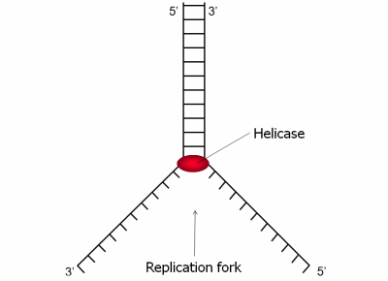
DNA POLYMERASE | 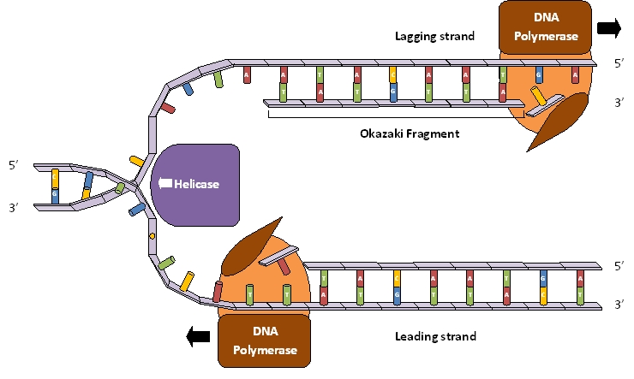
COMPLEMENTARY | 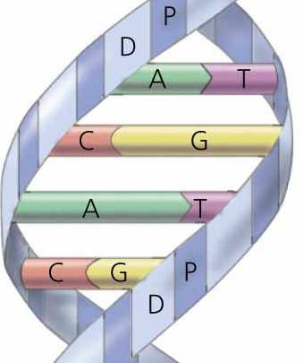
LIGASE | 