DNA Structure
- DNA stands for _________________________________________ and makes up the
chromosomes in the nucleus of ever cell.

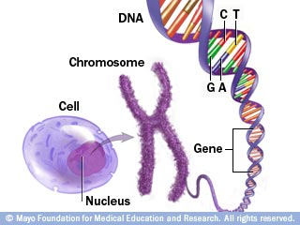
- DNA controls what kind of cell a cell will become
  - Ex) _______________________________________________________________
- DNA controls what kind of organism something is
  - Ex) _______________________________________________________________
- DNA controls what the organism will look like
  - Makes up the _________________
- DNA is made up of smaller parts called _______________________________
  - Each nucleotide is made out of
    - 1 sugar called ____________________
    - 1 ________________________ group
    - 1 ________________________ base
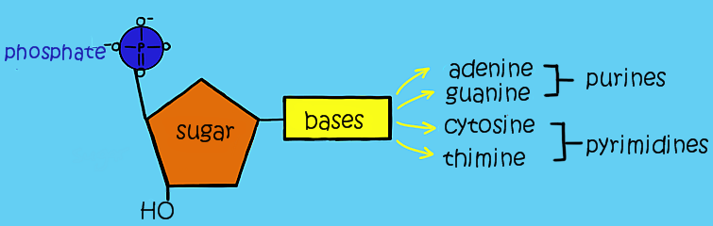

- Nucleotides connect end to end by _________________________ bonds along their “sugar-phosphate backbone”
  - These bonds are very strong
- Two separate strands come together and connect by ____________________ bonds between their bases
  - These bonds are very ____________
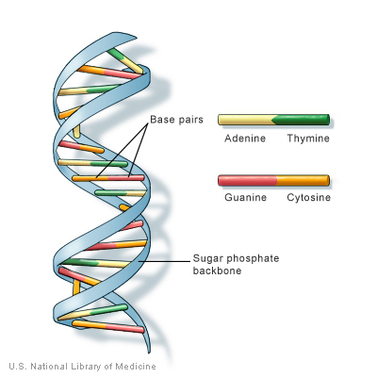
Rosalind Franklin used a process called ___________________________________ to get a picture of DNA
- James Watson and Francis Crick build a model and found out that DNA was structured like a _____________________________________.
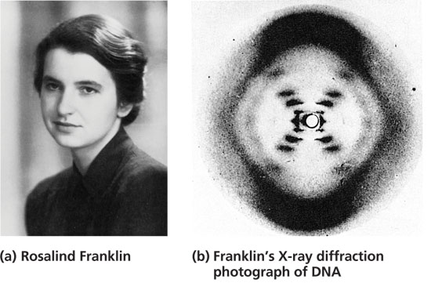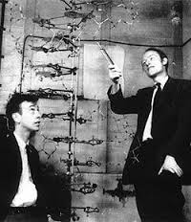

- Nitrogenous bases come in pairs
  - Adenine ______________________ and Guanine ____________________
- A & G are ____________________ T & C are ____________________________
- Chargaff’s Rule
  - Only A & T can bond with one another
  - Only G & C can bond with one another

