Population Ecology Vocabulary

AGE STRUCTURE
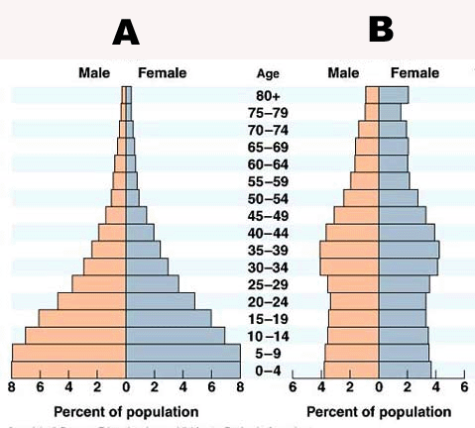

SURVIVORSHIP CURVES
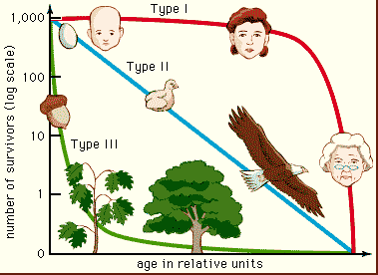

GROWTH CURVES
EXPONENTIAL MODEL LOGISTIC MODEL
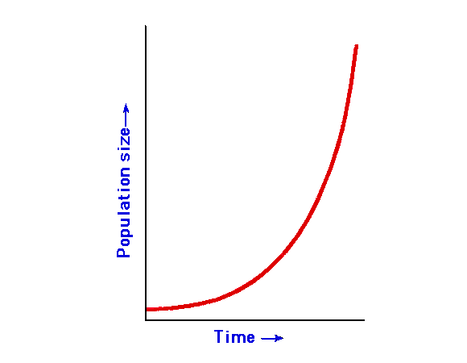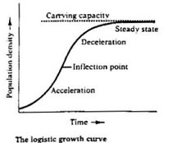

- Limiting factor – a factor that ________________ the growth of a population.
- __________________ increases as _______________ increases.
- Density-Independent Factors – reduce the population by the ______ proportion regardless of population size. (______________, floods and ____________)
- Density-Dependent Factors – reduce the population by an amount _____________________ to the population size. (shortage of ___________, shortage of nesting sites and __________________)

