NAME_______________________
PERIOD_______________________
Pedigree Analysis Homework
Albinism is a recessive trait in humans, where there is a lack of pigment in the skin and hair causing the person to look pale with white hair. The following three pedigrees trace the inheritance of the recessive allele that causes albinism.
- Given the following genotypes, describe the phenotypes (normal or albino).
AA = ____________________________
Aa = ____________________________
aa = ____________________________

- Fill out the pedigree below (AA, Aa, or aa). Also label the generations using roman numerals and the individuals using numbers. (REFER TO YOUR NOTES!)
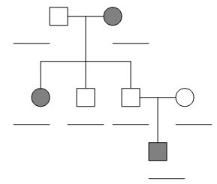

- How many children does the original couple have? _________________________

- How many grandchildren does the original couple have? _____________________

