Polygenetic traits
•Traits that are _____________ by more than one gene.
–Ex. Skin color and _______ color
Eye color
•There are three ________ eye colors.
–1. Brown – a lot of _____________ pigment
–2. Red- no melanin and we see the _________.
–3. Blue- a _________ amount of melanin in the lower layer of the ______ which reflects blue light waves.
•This does not explain the _______________ of colors.
•So it can’t be that simple!

•There are at least three __________ responsible for eye color.
•Chromosome 15 - bey 2 Brown/blue
•Chromosome 15 - bey 1 Brown/nothing
•Chromosome 19 - gey Green/blue
Blue Eyes
•In order to have blue eyes you need to have all three genes indicate blue or _____________.
• bey 2 - Brown/blue blue
• bey 1 - Brown or nothing nothing
• gey - Green/blue blue
Brown eyes
•Individuals with brown eyes have one of the _______ genes expressing brown. IF one is brown, it will ___________ the other colors.
•bey 2 - Brown/blue blue
•bey 1 - Brown or nothing brown
•gey - Green/blue green
Green eyes
•For green eyes, the two __________ genes are not expressed and the green gene is ________.
•bey 2 - Brown/blue blue
•bey 1 - Brown or nothing nothing
•gey - Green/blue green
Other colors
•Scientists are not sure exactly how to get _____________ but this is their latest idea.
•They gey gene has a second gene which ______________ the amount of melanin produced.
•M= modifier
–MM or Mm will produce __________ eyes
– _______ will produce green eyes

Violet eyes
•Genetically similar to __________ eyes
•Extremely ___________.
Different color eyes
•_________________________
•Both eyes are ____________________ colored or one eye has two different colors.
•Many causes: trauma at birth, joining of ____________ in the womb, etc…

Changes in Chromosome ______________

- Changes in chromosome number are important for _______ and evolution
- ______________ syndrome is caused by a change in chromosome number.

Aneuploidy

- Aneuploidy occurs when one of the _________________ is present in an ____________ number of copies.
- ___________________ and monosomy are two forms of aneuploidy.

Down Syndrome is Caused by ____________ for Chromosome _______

- Aneuploidy is remarkably _________, causing termination of at least _______% of human conceptions.
- Aneuploidy is also a driving force in _____________ progression (virtually all cancer cells are ________________).

Chromosome ______________________ in Meiosis Causes Aneuploidy
The Frequency of Down Syndrome Rises Sharply with Age of the ______________

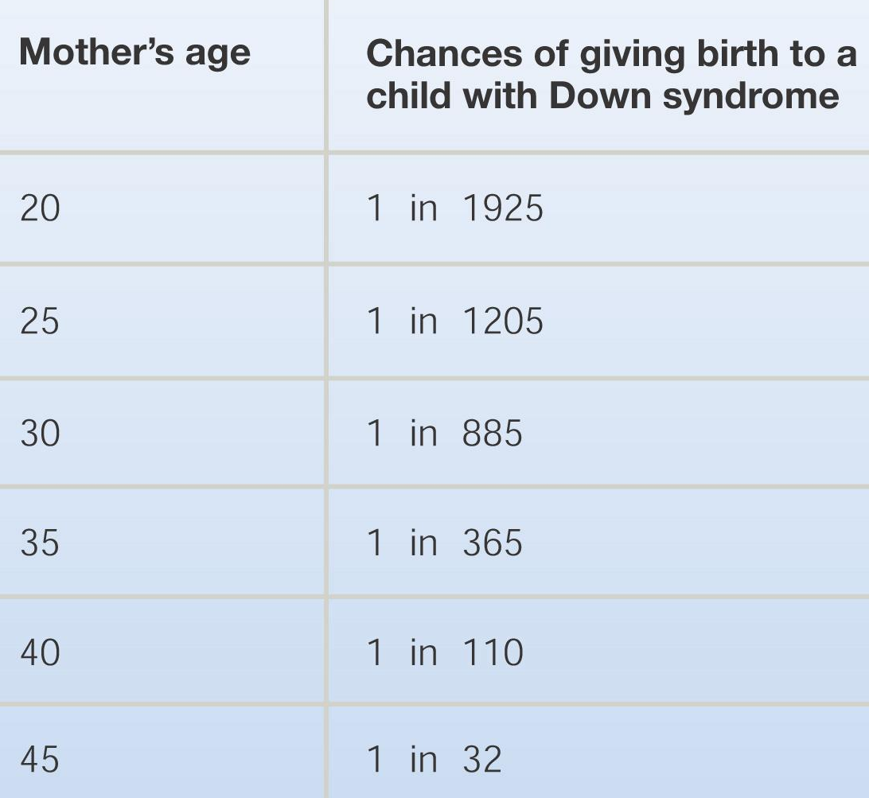

Sex _________________ Aneuploid Conditions are _____________

Polyploidy

- Polyploidy occurs when all the chromosomes are present in _______ or more copies.
- Polyploidy is common in __________ and rare in ___________.
- Polyploids are ___________ when chromosome number ______________.
- A common way for this to occur is for the _____________ fibers to fail, leaving all chromosomes in ________ cell.
- Roughly 35% of ______________ plants (the most familiar plant species) arose through polyploidization.
- Most crop species are polyploid.

Chromosome Structural Changes
- There are ____ types of chromosome structural change – all of them associated with human ______________.

- Cri-du-Chat _______ – a debilitating disorder caused by chromosome _____________.
- Cri-du-Chat is caused by the ________ of the short arm of one copy of chromosome ___

Searching for Chromosomal _________ - ________________ and Chorionic Villus Sampling

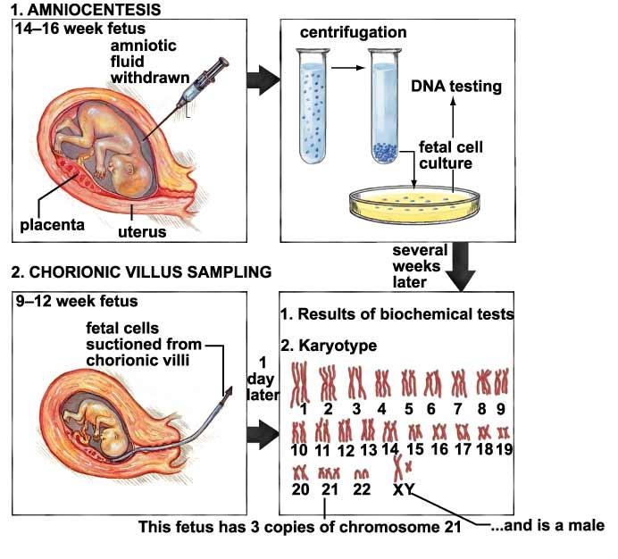
- Pre-Implantation Genetic Diagnosis (_____) - Removing a ______ for diagnosis from a human _____________.

