Individual Ecology
Environmental Factors

- Biotic factors -

- Abiotic factors –

- Abiotic factors are not ____________________________.

Responding to a Changing Environment

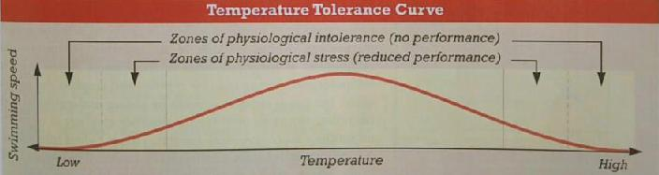

- Tolerance curve –

- Acclimation -

- Elevation acclimation
  - Reduced oxygen levels
  - Number of ______________________________________ increase to allow for more oxygen that your blood can carry
- Acclimation vs. Adaptation
  - Acclimation occurs within organism’s ____________________________
  - Adaptation is a genetic change in a species over many __________________

Control of Internal Conditions

- Conformers –

  - Example:

- Regulators –

  - Example:

Escape from Unsuitable Conditions

- Dormancy –

- Migration –

The Niche

- Definition –

- The niche includes:
  - Range of _______________________ it can tolerate
  - Methods by which it obtains ________________________
  - Number of _____________________ it has
  - Its time of __________________________
  - All other __________________________ with its environment

2 Types of Niches

- Fundamental Niche – range of conditions that a species can __________________________ tolerate and the resources it can __________________________ use.

- Realized Niche – range of resources the species ____________________ uses.

2 Types of Organisms

- Generalists – species with a broad niche

- Specialists – species with a narrow niche

