Pedigree Worksheet

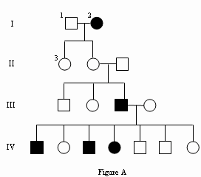
- Interpreting a human pedigree

Use Figure A to answer the questions below.

1. Number all individuals on the pedigree at the top of each shape.
2. In a pedigree, a square represents a male. If it is darkened he has
hemophilia; if clear, he had normal blood clotting.
a. How many males are there?
b. How many males have hemophilia?

3. A circle represents a female. If it is darkened, she has hemophilia; if open she is normal.
a. How many female are there?
b. How many females have hemophilia?

4. A marriage is indicated by a horizontal line connecting a circle to a square.
a. How many marriages are there?

5. A line perpendicular to a marriage line indicates the offspring. If the line ends with either a circle or a square, the couple had only one child. However, if the line is connected to another horizontal line, then several children were produced, each indicated by a short vertical line connected to the horizontal line. The first child born appears to the left and the last born to the right.
a. How many children did the first couple (couple in row I) have?
b. How many children did the third couple (couple in row III) have?

6. Level I represent the first generation, level II represents the second generation.
a. How many generations are there?
b. How many members are there in the fourth generation?

B. Determining the pattern of inheritance and assigning genotypes.

When working through a pedigree, the first thing you need to do is figure out which characteristic is dominant-the shaded one or the open one. Then you need to choose a letter (let’s use A) and begin assigning genotypes. Remember that recessive individuals are always homozygous, so assign their genotypes first. Then go back and look at all of the dominant individuals. For some, you will only be able to determine one allele of the genotype, so just write the one capital allele followed by a dash (A__).

Fur Color in Mice

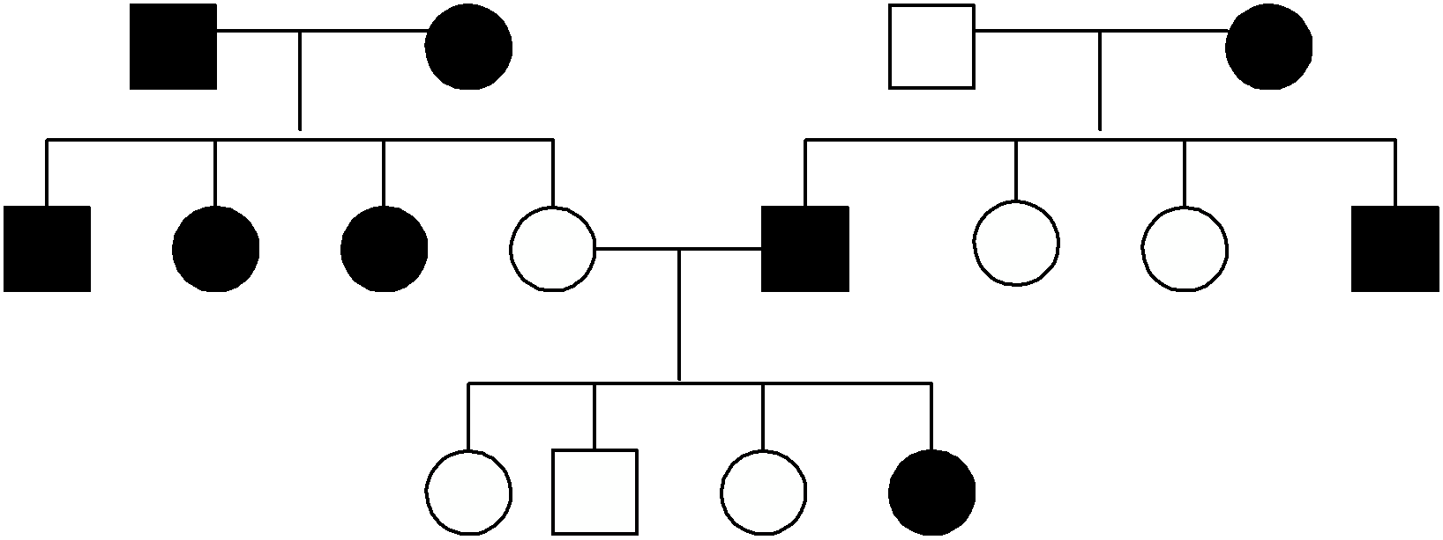
1. Which characteristic is dominant?

.

Which characteristic is recessive?

.

2. Determine the genotypes of all individuals. You will have three (A___)s. Write your genotypes beneath each individual.

= white female = black female

= white male = black male

