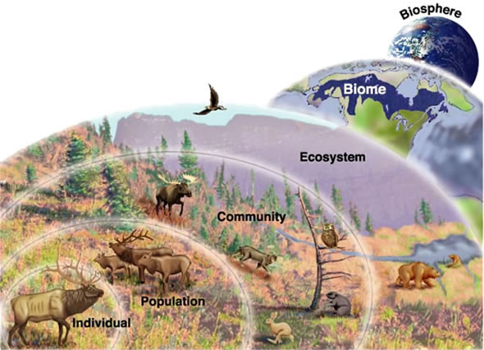

Ecology - Levels of Organization

*Largest*

*Smallest*