Introduction to the Microscope
3 Types of Microscopes

- ____________________________________________________
  - 2-D or 3-D
  - high or low magnification
  - high or low resolution (picture quality)
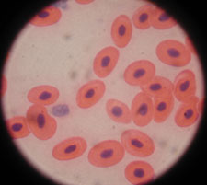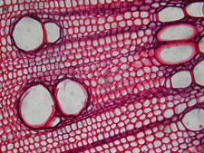

- ____________________________________________________
  - 2-D or 3-D
  - high or low magnification
  - high or low resolution (picture quality)
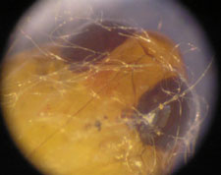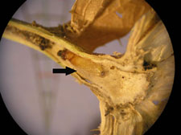

- _____________________________________________________
  - 2-D or 3-D
  - high or low magnification
  - high or low resolution (picture quality)
