Name Period Date

DNA: The Molecule of Heredity Worksheet

DNA Structure

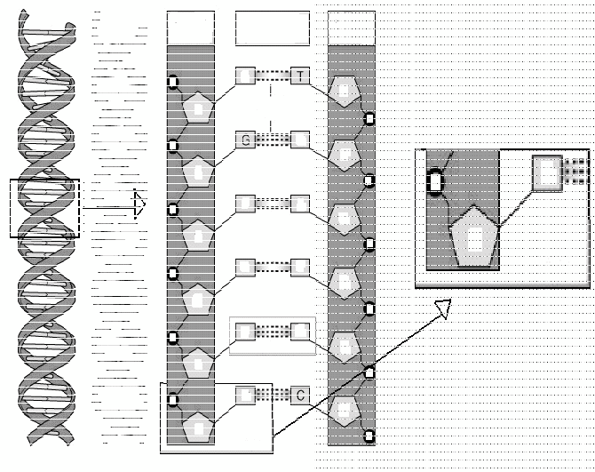
1. On the diagram to the right:

x Circle and label a nucleotide.

x Label the sugar and phosphate molecules.

x Label the bases that are not already labeled.

x Label a base pair.

x Label the sugar-­
phosphate backbones.

x Label the hydrogen
bonds.

2. A nucleotide is made of three parts: a group, a five carbon
, and a base.

3. In a single strand of DNA, the phosphate group binds to the of the next group.

4. Chargaff's rule states that the DNA of any species contains equal amounts of
& and also equal amounts of
& .

5. In DNA, thymine is complementary to (or pairs with) ;; cytosine is complementary to .

6. In a strand of DNA, if the percentage of thymine is 30%, what would the percentage of cytosine in the same DNA strand be? .

7. James Watson and Francis Crick with, the help of Rosalind Franklin and others, determined that the shape of the DNA molecule was a .

8. What type of bonds connect the deoxyribose sugars to the phosphate groups?

9. What type of bonds connect the bases to each other?

