Classic Genetics a.k.a. Mendelian Genetics - Page 1

Vocabulary
- Genetics:

- Allele:

- Genotype:

- Phenotype:

- Dominant:

- Recessive:

- Homozygous:

- Heterozygous:

- Mendel and His Peas
- Principles of genetics were developed in the mid __________ ___________________ by _________________ ___________________ an Austrian Monk
- Experimented with ___________ plants, by crossing various __________________ and _____________________________ the characteristics of their ________________________.

Generations - Page 2
- P – __________________________ Generation
- F₁ – 1st __________________ Generation
- F₂ – 2nd __________________ Generation
- Filial = _____________ or _______________________
Law of Segregation
- When __________________________ (sperm & egg) are formed each gamete will ________________________ one allele or the ___________________.
Law of Independent Assortment
- _______________ or more alleles will separate ____________________________________ of each other when _________________________________ are formed (not all people with _______________ eyes also have _______________________ hair)
Molecular Genetics
- Study of the ______________________________ and function of ______________________________________ and genes.
Genotype vs. Phenotype
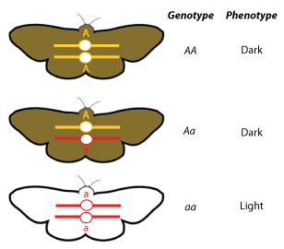
Homozygous vs. Heterozygous - Page 3
- HOMOzygous Dominant= _______________
- HOMOzygous Recessive = _______________
- HETEROzygous = ____________________

Predicting Results of Breeding
- Genetic _______________________ can be easily solved using a tool called a ___________________________ square.
  - Tool for calculating genetic _______________________________
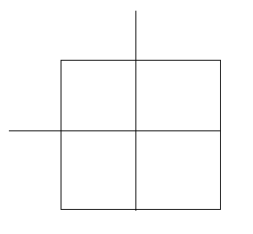
- Monohybrid Cross (cross with only 1 trait)
Problem:
- Using this is a several step process, look at the following example
  - Tallness (T) is dominant over shortness (t) in pea plants. A Homozygous tall plant (TT) is crossed with a short plant (tt). What is the genotypic makeup of the offspring? The phenotypic makeup ?

Punnett Process - Page 4
- Determine _____________________ of each parent, these are given as TT, and tt.
- Take each possible allele of each _________________, _______________________ them, and place each allele either along the ______________, or along the ________________ of the ______________________ square.
- Lastly, write the letter for each allele across each ____________________ or down each ____________. The resultant ________________ is the _________________________ for the offspring.
- Lets take this a step further and cross these F1 __________________ (Tt) to see what ________________________ and phenotypes we get.
- Since each parent can contribute a T and a t to the offspring, the punnett square should look like this…
Dihybrid Cross (Cross with 2 traits) - Page 5
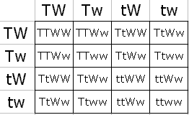
- Genotypic Ratio -
- Phenotypic Ratio -

Incomplete Dominance
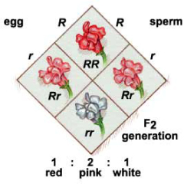
Codominance
- Neither __________________ is dominant or ______________________.
